Friendship
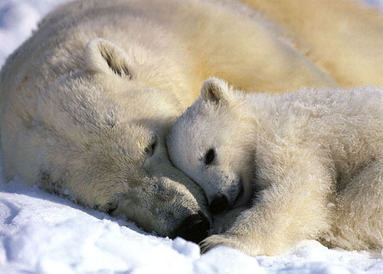
Many people will come in and out of your life
But only true friends leave a footprint in your heart.

To deal with yourself, use your head;
to deal with others, use your heart;
anger is the only dangerous word ...

If someone betrays you once, it’s their fault;
if someone betrays you twice, it’s your fault.

Great minds discuss ideas;
medium minds discuss events
small minds argue with people.

Those who loose money, loose a lot;
Those who loose a friend; loose more;
Those who loose faith, loose everything...

Beautiful youth are accidents of nature;
Beautiful elderly are works of art.

Learn with the mistakes of others,
You don’t live long enough to make all of them.

Friends you and I…
You brought another friend…
Now we are three…
We started a group .
Our circle of friends…
And like a circle,
It has neither beginning nor end ...

Yesterday is history;
Tomorrow is a mystery,
Today is a present,
That’s why we call it present...

Spread some cheer to your friends!

